Lab Assignment 8 - SQL Joining

## Instructions

1. Answer the below question in the boxes.
2. Please submit the assignment through TalentLabs Learning System.

## Open the Movies database

Follow the step illustrated in Chapter 3 to open the Movies database using DB Browser for SQLite. You should see 5 tables in the database.

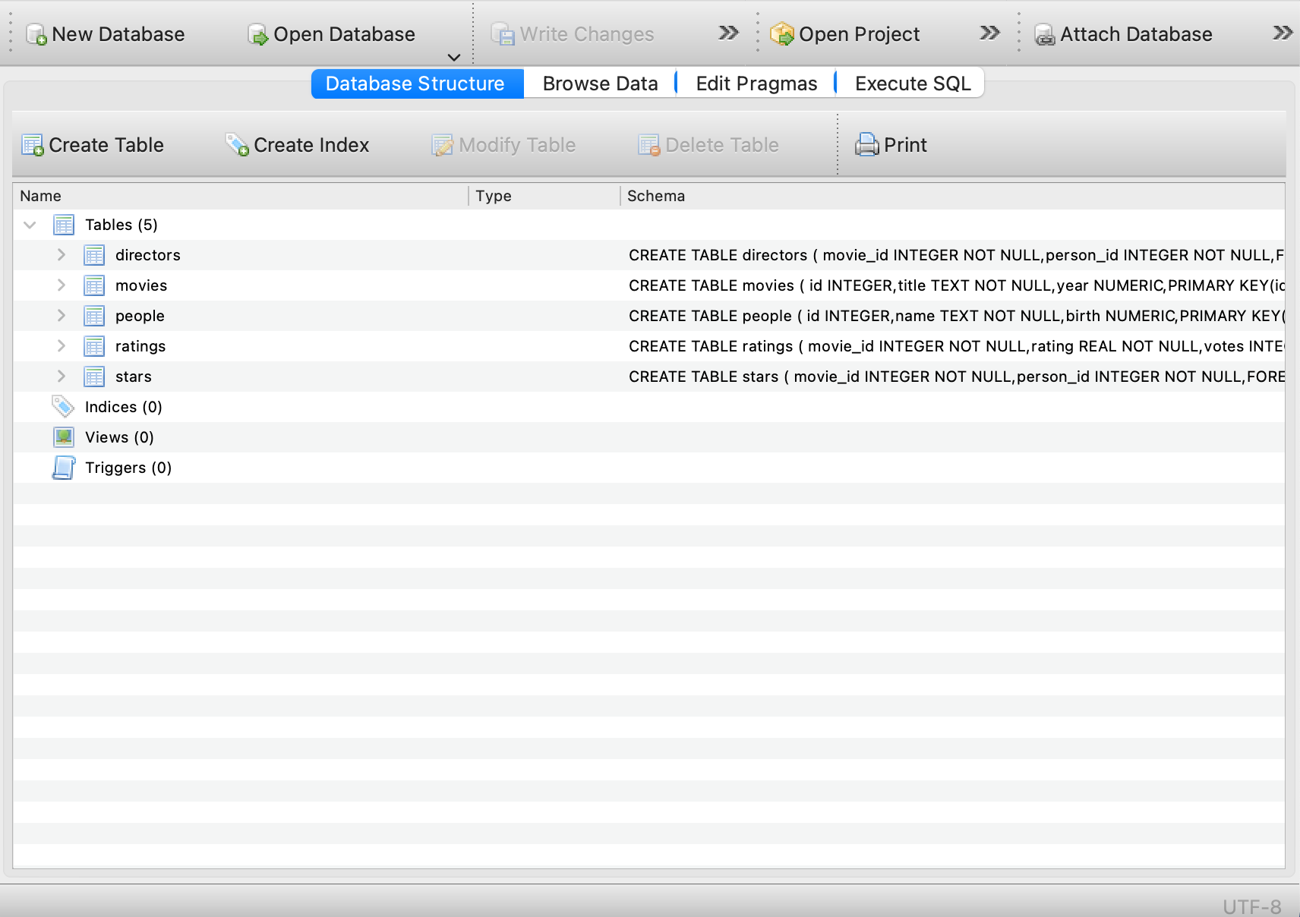

## Query Exercises

1. Write a SQL query to determine the average rating of all movies released in 1998.

Expected Output: a table with a single column and a single row (plus optional header) containing the average rating.

|  |
| --- |
| SELECT AVG(rating) AS AverageRating FROM movies JOIN ratings ON movies.id= ratings.movie_id WHERE year=1998 |

1. Write a SQL query to list all movies released in 2002 and their ratings, in descending order by rating. For movies with the same rating, order them alphabetically by title.

Output: a table with two columns, one for the title of each movie and one for the rating of each movie. Movies that do not have ratings should not be included in the result.

|  |
| --- |
| SELECT title,rating FROM movies JOIN ratings ON movies.id= ratings.movie_id WHERE year=2002 ORDER BY rating DESC, title ASC |

1. Write a SQL query to list the names of all people who starred in “The Lord of the Rings”.

Hint: You need to do 2 joins to achieve that. Still remember how to use subqueries?

Output: a table with a single column for the name of each person. You may assume that there is only one movie in the database with the title The Lord of the Rings.

|  |
| --- |
| SELECT name FROM (movies JOIN stars ON movies.id=stars.movie_id) a JOIN people ON people.id = a.person_id WHERE title='The Lord of the Rings' |

1. Write a SQL query to list the names of all people who starred in a movie released in 2010, ordered by birth year in ascending order.

Hint: You need to do 2 joins to achieve that. Also, you will need to use DISTINCT to make sure each name appears once only.

Output: a table with a single column for the name of each person. People with the same birth year may be listed in any order. No need to worry about people who have no birth year listed, so long as those who do have a birth year are listed in order. If a person appeared in more than one movie in 2010, **they should only appear in your results once.**

|  |
| --- |
| SELECT DISTINCT name FROM (movies JOIN stars ON movies.id=stars.movie_id) a JOIN people ON people.id = a.person_id WHERE year=2010 ORDER BY birth ASC |

1. Write a SQL query to list the names of all people who have directed a movie that received a rating > 8.5.

Hint: You will need to use 2 joins to solve this question.

Expected Output: a table with a single column for the name of each person.

|  |
| --- |
| WITH  ratingmovies AS  (SELECT movie_id FROM ratings WHERE rating >8.5)  SELECT name FROM (movies JOIN directors ON movies.id=directors.movie_id) a JOIN people ON people.id = a.person_id  WHERE movie_id IN ratingmovies |

1. Write a SQL query to list the titles of the five highest rated movies (in order) that Leonardo DiCaprio starred in, starting with the highest rated.

Hint: If you find it too difficult to do it in one SQL query, feel free to loop up the id of Leonardo DiCaprio in the people table first.

Expected Output: a table with a single column for the title of each movie. You may assume that there is only one person in the database with the name Leonardo DiCaprio.

|  |
| --- |
| WITH  personID AS  (SELECT id FROM people where name LIKE "Leonardo DiCaprio"),  movieID AS  (SELECT movie_id FROM stars where person_id IN personID)  SELECT title from movies JOIN ratings ON movies.id = ratings.movie_id where id IN movieID  ORDER BY rating DESC LIMIT 5 |

**- End of Assignment -**